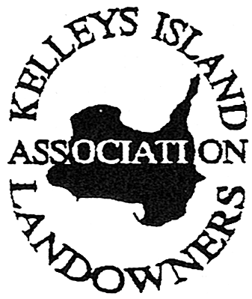

P O BOX 22, Kelleys Island OH 43438
March 2018

Our Objectives: The objectives of the Kelleys Island Landowners Association are to preserve the tranquility and beauty of this island by remaining constantly alert and vigilant to any situation that could adversely affect the needs of our members and the island itself. We provide a forum where members can have the opportunity to present ideas, problems, and information; and we bring all available information regarding Kelleys Island to the Village Council and our members.
President’s Message

Dear KILA Members,

Thank you for a wonderful 2017! KILA members should be very proud of the activities and events from the past year. So many people were involved and we’re looking forward to getting more and more of you active within our organization. As always, we meet on the 3rd Saturday of each month at Estes school. All KILA members are welcome to attend.

Each year KILA will be raising funds for an island improvement project/helping other island community organizations. Last year KILA led the fundraising for the beautiful new memorial park lights. Several Island residents graciously donated as well, to ensure the light project would be completed within 2017. The names of all donors are on each light pole. I want to thank each one of them for working with KILA to make this happen. In 2016, KILA raised enough funds for the Pavilion at the Ball Field to be refurbished, painted and cleaned! Thank you all!!! KILA is a NON-PROFIT organization and we work for you, the homeowner. KILA has a rich history of helping community needs of the island and will always work to better the Island we love.

Please plan to attend our KILA events this year!
- Pot Luck - Our beginning of the season Pot Luck is always a hit! Mark your calendars and plan to attend our 2018 Pot Luck at the Pavilion / ball field on June 16th.
- Island Fest - Stop by the KILA booth at Island Fest on July 13, 14 & 15 to see/buy KILA’s new 2018 T-shirt designs. Buy a KILA raffle ticket for the 2018 KILA Island Improvement. It’s also a good time to volunteer for our annual Homecoming festivities!
- Homecoming – Speaking of Homecoming, this year we’re expanding homecoming to a 2-day event! Join us Friday August 10th from 5-9pm & Saturday August 11th from 12-4pm. This year Homecoming will be held a week earlier than usual to allow families who have to return home because of the start of school, the opportunity to be on the island for the event. Friday night we’ll have a band, food and beer tent. Saturday’s parade will be at 11:00am followed by bands, food, kids bounce house, crafts and food vendors.
- Hay ride/family Halloween – This is one of the most family-fun events on the island. In 2017 we had a record number of families come to the 4-H camp for fun, games, food, hay ride and more. We hope to see you all there October 20th!

Again this year we will have the popular KILA membership cards issued this spring. We have included with this newsletter a reply envelope and dues slip. Simply fill it out and return it with a check for $10 to cover your 2018 annual dues and to be an active member. Return your dues before the April 30th deadline to receive your 2018 cards. If you have already paid your dues for 2018, Thank you!!!

Sincerely,

Chris Arnold
KILA President

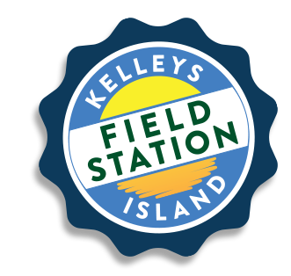
FIELD STATION INFORMATION

The Lake Erie Islands offer an unmatched learning and research environment. The KI Field Station seeks to promote and support environmental education, research and conservation. Students from all over Ohio visit the Kelleys Island Field Station for the field experience, to participate in Summer Programs and host adult lecture series events.

It's never too early to start thinking about summer! Check out the 2018 Summer Programs at kelleysislandfieldstation.org!

2018 YOUTH SUMMER PROGRAMS - Join us for a summer of fun and adventure! For kids 8-14 yrs. of age. Learn more at
KelleysIslandFieldStation.org, or call 419.746.9001 to register!

SEEKING ON-CALL NATURALISTS AND NATURE EDUCATORS - The Field Station is looking for naturalists and nature educators interested in helping us facilitate outdoor experiences for school and community groups – go to KelleysIslandFieldStation.org to learn more and apply today!

RESEARCH OPPORTUNITIES - Are you interested in conducting research on Kelleys Island? The unique setting of the Kelleys Island Field Station provides a great opportunity for scientific research for faculty, students, teachers, and engaged citizens. The sheer variety of natural habitats on Kelleys Island and the surrounding islands provide unmatched opportunities for research. Whether it’s an academic research study or a citizen science project we want to know how we can help!

The KELLEYS ISLAND SCHOOL BOARD announced a TAX ROLLBACK of 11 mills for 2017 (collected in 2018). This is the 18th year that property owners realized an almost 62% savings on the school portion of their tax bill. [One mill is one dollar per $1,000 dollars of assessed value.] As always we thank the school board for giving the islanders a tax break.

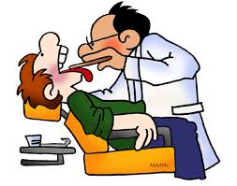
The ERIE COUNTY HEALTH DEPT. wants to know if the residents of Kelleys Island would like to see more services like additional health clinics (now once a month changing to once a week) and whether we would like to have a dental clinic visit the Island. Contact the Erie Co. Health Dept. and let them know! They can be reached at (419) 626-5623 between 8:00AM -5:00PM or call the 24 Hour Toll Free number (888) 399-6065; or email them at: echd@eriecohealthohio.org

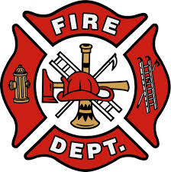
COUNCIL NEWS

The FIRE DEPT. has certified six new volunteers. They have SMOKE DETECTORS that they will install at your request and they can also work out a SAFETY PLAN for your home. The WATER DEPT. reports that faulty fire hydrants have been replaced and all the leaks have been found.

While the EPA HAS MANDATED and previously paid for bi-weekly ALGAE TESTS, this cost now becomes the responsibility of the Water Dept. ($200 for each bi-weekly test) and these tests must be done all year long.

The Village accepted the donation of a 1.61 acre parcel of LAND, just to the left of the entrance to the AIRPORT parking lot from Ericson Kelleys Island Properties.
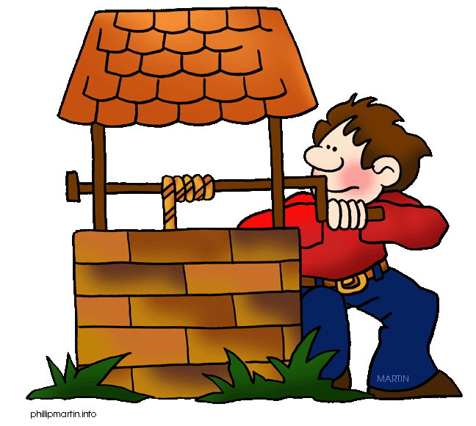
If your property has a WELL and you missed the free PRIVATE WELL EDUCATION PROGRAM put on by WSOS and the Erie County Health Dept., never fear, there are loads of resources to help you keep your well safe and healthful!! Erie County has a new lab that will TEST YOUR WATER for nitrates, e-coli, and coliforms for just $80. Contact them at 419-626-5623 (EXT) 115. Online classes and podcasts are available at PrivateWellClass.org and the Ohio Dept. of Health has articles and guidelines on how to disinfect your well (the correct way).

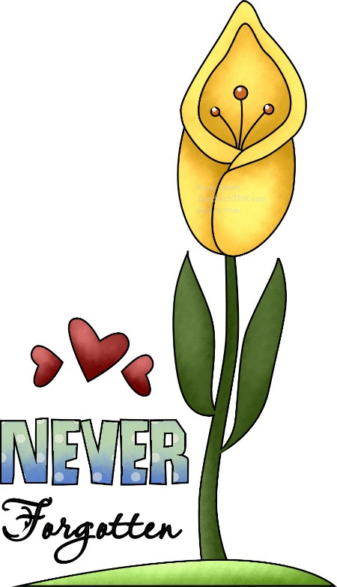
ISLAND DEATHS

PAUL E. MACK, 81, passed away March 19, 2017
DONALD HUNTLEY, SR., 83, passed away April 8, 2017
BARRY W. LANGE, 50, passed away August 19, 2017
DIANNE E. HACKER, 77, passed away August 25, 2017
ALBERT JOSEPH ‘ABE’ FRESCH, 91, passed away September 17, 2017
LEROY SILVANI, 89, passed away January 13, 2018
DANIEL DAVID AHNER, 87, passed away January 27, 2018

- - - - - - - - - - - - - - - - - - - - - - - - - - - - - - - - - - - - - - - - - - - - - - - - - - - - - - - - - - - - - - - - - - - - - -

KELLEYS ISLAND LANDOWNERS ASSOCIATION

KILA has donated thousands of dollars to island organizations. KILA is ready to work with other non-profit, charitable organizations to help make Kelleys Island a better place to live! If you have SUGGESTIONS for improvements that KILA can help make on the Island, let us know! You can E-MAIL us at: info@KelleysIslandLandowners.org.
Annual Dues

Date Description Amount Due

March 1, 2018 Annual KILA Dues $10.00

Please make checks payable to KILA and mail to: PO Box 22, Kelleys Island, OH 43438. For your convenience, you can also pay by PayPal at: http://www.kelleysislandlandowners.org/membership.php

Name ________________________________________

Address ________________________________________

City/State/Zip ________________________________________

E-Mail address ________________________________________

Phone Number ________________________________________

